AI ASSISTANT CODING
ASSIGNMENT-11
NAME: Thrishala Jakkaraju
HALLTICKET:2303A51514
BATCH:22

Task Description #1 – Stack Implementation
Task: Use AI to generate a Stack class with push, pop, peek, and is_emptymethods.
Sample Input Code:
class Stack:
pass

code:
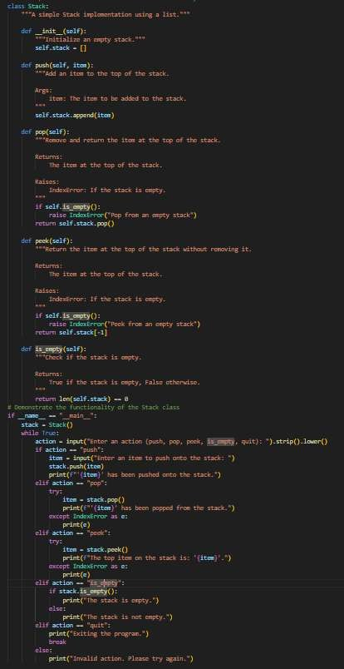

Expected Output:
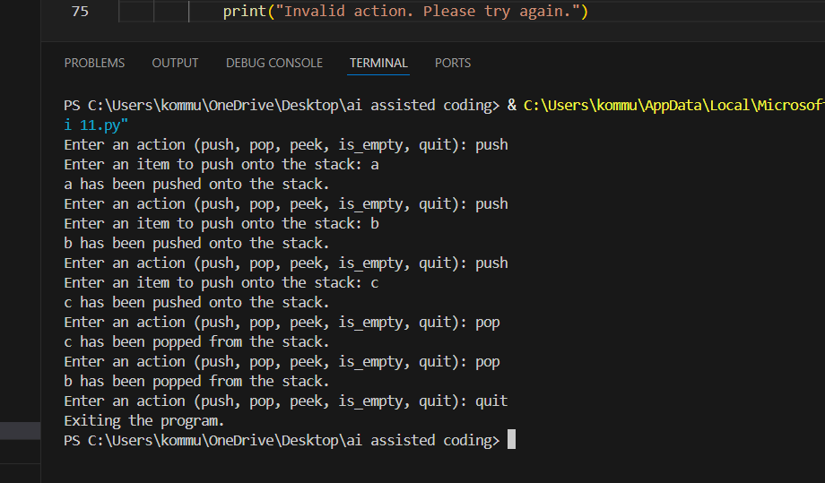
• A functional stack implementation with all required methods and docstrings.

Observation: The Stack class works correctly by following the Last In, First Out (LIFO) principle, where the most recently pushed element is removed first. The push, pop, peek, and is_empty methods perform as expected, including proper handling of edge cases like popping or peeking from an empty stack. The interactive user input successfully demonstrates the functionality and error handling of the stack implementation.

Task Description #2 – Queue Implementation
Task: Use AI to implement a Queue using Python lists.
Sample Input Code:
class Queue:
pass
code:
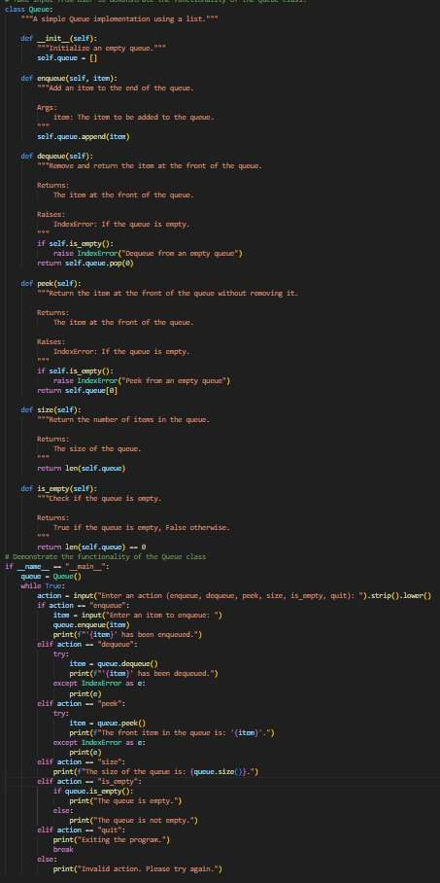
Expected Output:
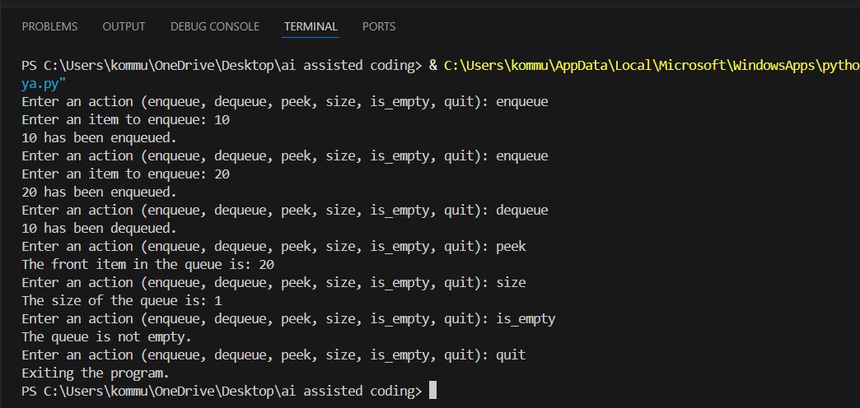
• FIFO-based queue class with enqueue, dequeue, peek, and size methods.

Observation: The Queue class correctly follows the First In, First Out (FIFO) principle, ensuring that elements are removed in the same order they were added. All methods including enqueue, dequeue, peek, and size function properly and handle edge cases like empty queue operations. The implementation effectively demonstrates queue behavior using Python lists.

Task Description #3 – Linked List
Task: Use AI to generate a Singly Linked List with insert and display methods.
Sample Input Code:
class Node:
pass
class LinkedList:
pass

code:
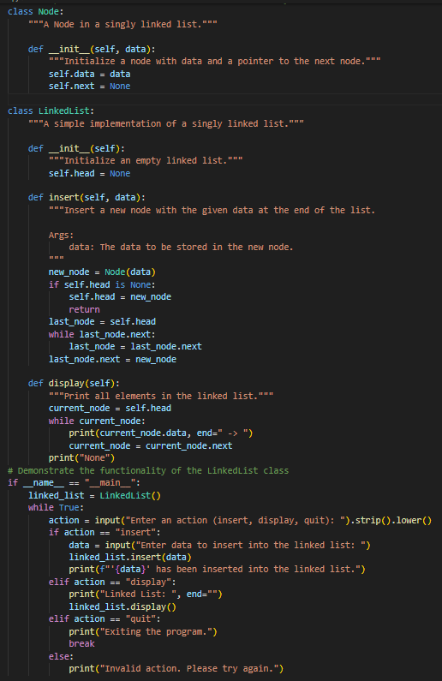

Expected Output:
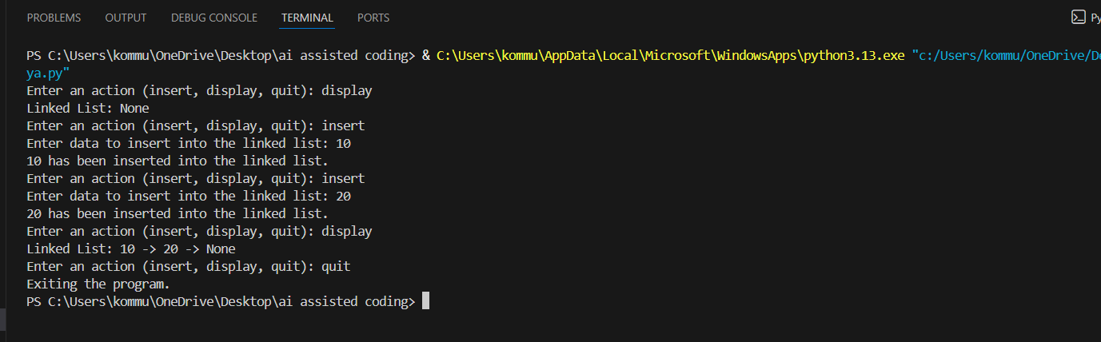
• A working linked list implementation with clear method
documentation.
Observation: The Singly Linked List correctly stores elements in sequential order using node connections. The insert method successfully adds elements at the end of the list, and the display method prints all nodes clearly. The implementation also handles the empty list case properly without errors.

Task Description #4 – Hash Table
Task: Use AI to implement a hash table with basic insert, search, and delete methods.
Sample Input Code:
class HashTable:
pass

code:
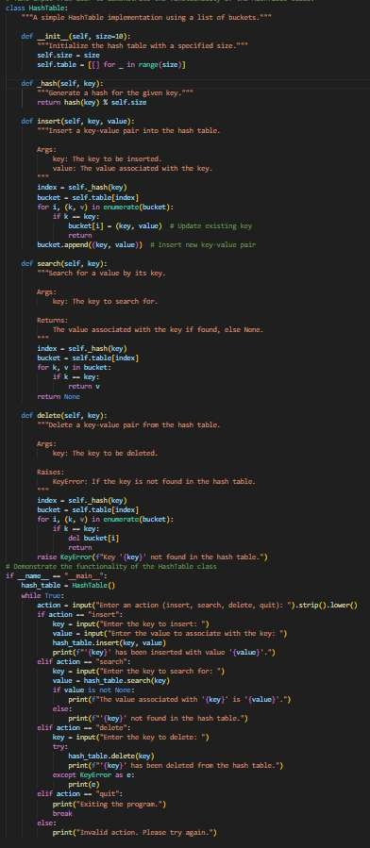
Expected Output:
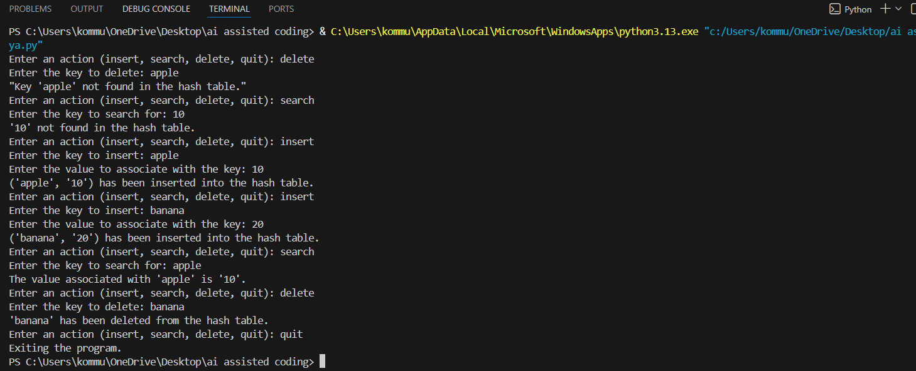
• Collision handling using chaining, with well-commented methods.

Observation: The hash table correctly stores and retrieves key-value pairs using a hash function and chaining for collision handling. The insert, search, and delete operations work efficiently even when multiple keys map to the same index. Edge cases such as deleting or searching for non-existing keys are handled properly without crashing the program.

Task Description #5 – Graph Representation
Task: Use AI to implement a graph using an adjacency list.
Sample Input Code:
class Graph:
pass

code:
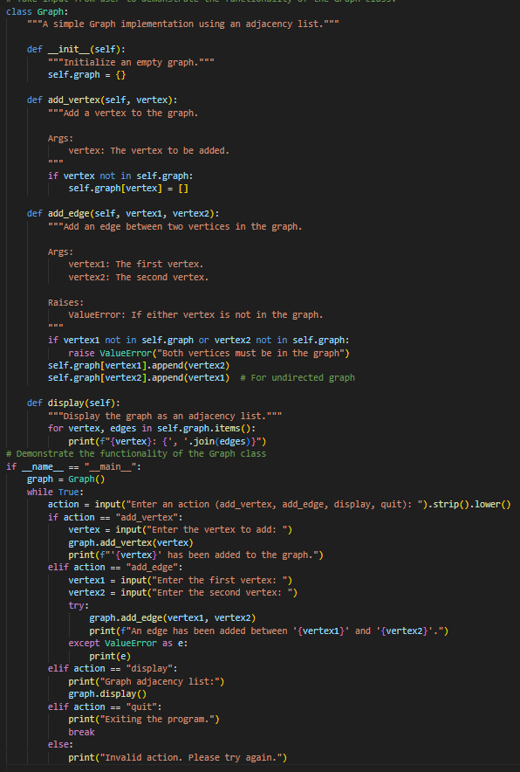

Expected Output:
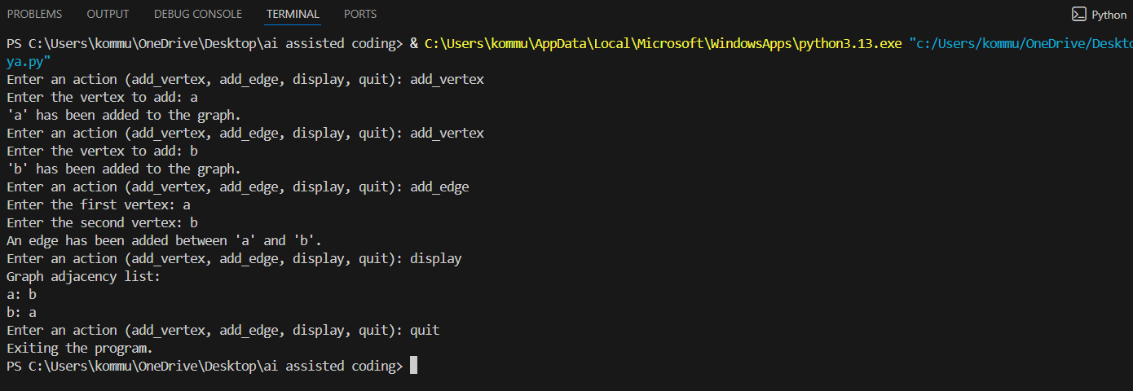
• Graph with methods to add vertices, add edges, and display
connections.
Observation: The graph implementation correctly stores vertices and edges using an adjacency list structure. The add_vertex and add_edge methods properly update connections between nodes in an undirected manner. The display method successfully shows all vertices along with their connected neighbors, confirming correct functionality.

Task Description #6: Smart Hospital Management System – Data Structure Selection
A hospital wants to develop a Smart Hospital Management System that handles:
1. Patient Check-In System – Patients are registered and treated in order of arrival.
2. Emergency Case Handling – Critical patients must be treated first.
3. Medical Records Storage – Fast retrieval of patient details using ID.
4. Doctor Appointment Scheduling – Appointments sorted by time.
5. Hospital Room Navigation – Represent connections between wards and rooms.
Student Task
• For each feature, select the most appropriate data structure from the list below:
o Stack
o Queue
o Priority Queue
o Linked List
o Binary Search Tree (BST)
o Graph
o Hash Table
o Deque
• Justify your choice in 2–3 sentences per feature.
• Implement one selected feature as a working Python program with
AI-assisted code generation.

Code:
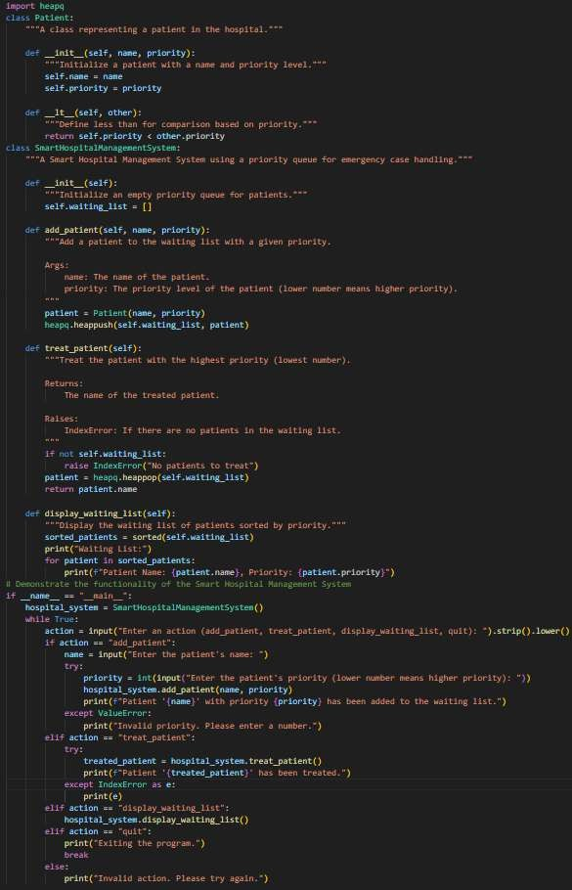
Expected Output:
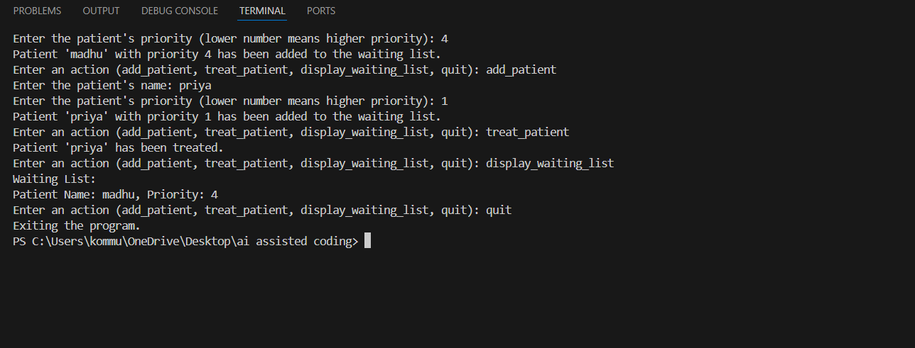
• A table mapping feature → chosen data structure → justification.
• A functional Python program implementing the chosen feature
with comments and docstrings.
Observation: The Priority Queue ensures that patients are treated based on the severity of their condition rather than their arrival time. Patients with critical conditions are given higher priority and attended to first, which supports effective emergency management. The system also properly handles situations when no patients are waiting and maintains efficient performance during patient insertion and treatment.

Task Description #7: Smart City Traffic Control System
A city plans a Smart Traffic Management System that includes:
1. Traffic Signal Queue – Vehicles waiting at signals.
2. Emergency Vehicle Priority Handling – Ambulances and fire trucks
prioritized.
3. Vehicle Registration Lookup – Instant access to vehicle details.
4. Road Network Mapping – Roads and intersections connected
logically.
5. Parking Slot Availability – Track available and occupied slots.
Student Task
• For each feature, select the most appropriate data structure from
the list below:
o Stack
o Queue
o Priority Queue
o Linked List
o Binary Search Tree (BST)
o Graph
o Hash Table
o Deque
• Justify your choice in 2–3 sentences per feature.
• Implement one selected feature as a working Python program with
AI-assisted code generation.

Code:
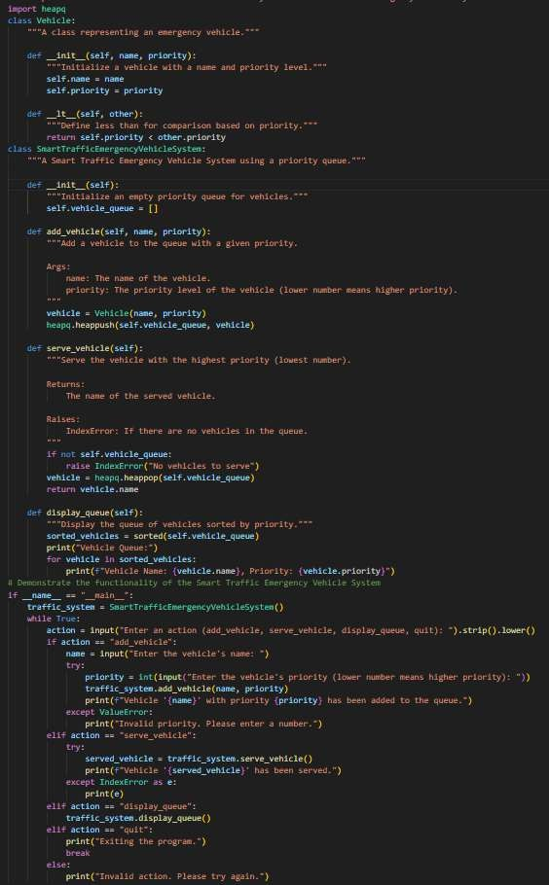
Expected Output:
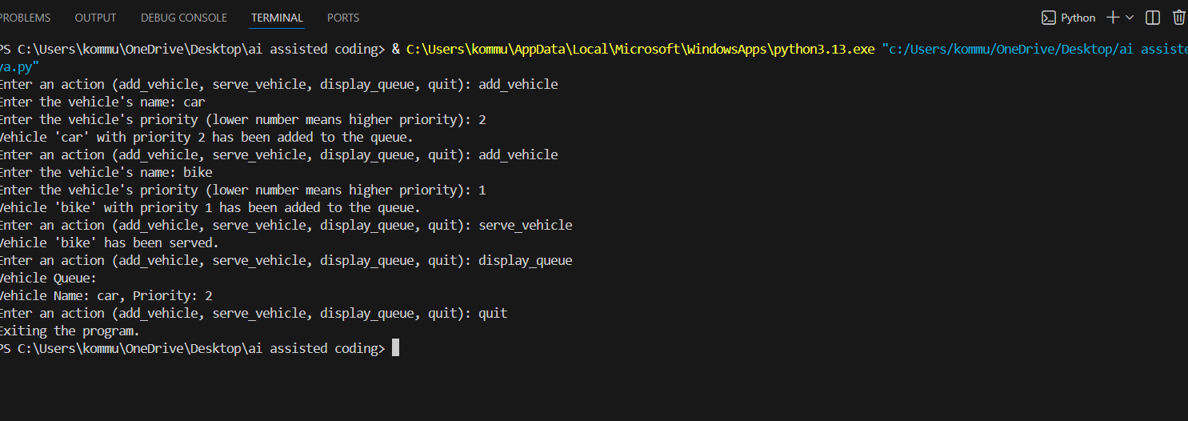
• A table mapping feature → chosen data structure → justification.
• A functional Python program implementing the chosen feature
with comments and docstrings.
Observation: The Priority Queue ensures that emergency vehicles such as ambulances and fire trucks are served before normal vehicles regardless of arrival order. This structure was chosen because traffic management requires priority-based handling rather than simple FIFO processing. The implementation successfully demonstrates efficient insertion and removal based on priority levels.

Task Description #8: Smart E-Commerce Platform – Data Structure
Challenge
An e-commerce company wants to build a Smart Online Shopping System
with:
1. Shopping Cart Management – Add and remove productsdynamically.
2. Order Processing System – Orders processed in the order they areplaced.
3. Top-Selling Products Tracker – Products ranked by sales count.
4. Product Search Engine – Fast lookup of products using product ID.
5. Delivery Route Planning – Connect warehouses and deliverylocations.
Student Task
• For each feature, select the most appropriate data structure from
the list below:
o Stack
o Queue
o Priority Queue
o Linked List
o Binary Search Tree (BST)
o Graph
o Hash Table
o Deque
• Justify your choice in 2–3 sentences per feature.
• Implement one selected feature as a working Python program with
AI-assisted code generation.

Code:
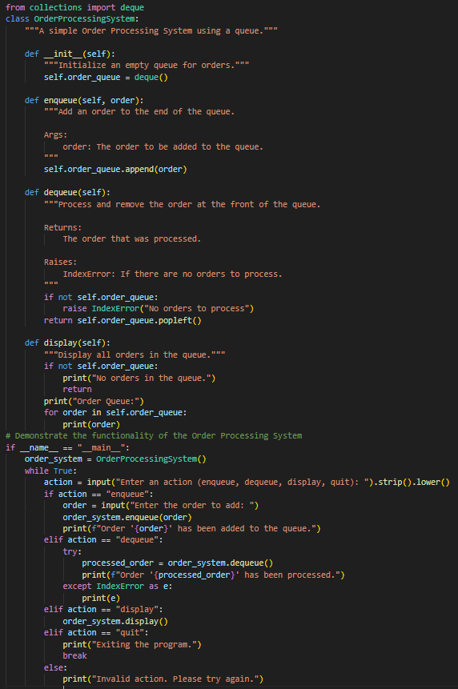
Expected Output:
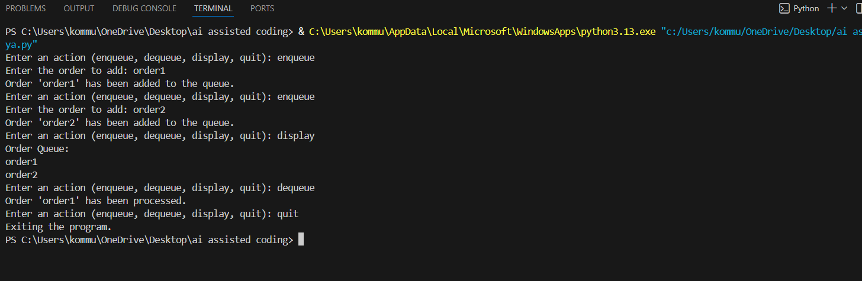
• A table mapping feature → chosen data structure → justification.
• A functional Python program implementing the chosen feature
with comments and docstrings.

Observation: The Order Processing System correctly follows the FIFO principle, ensuring fairness in handling customer orders. The Queue data structure was chosen because it processes elements in the exact order they are inserted. This makes it the most suitable and logical structure for managing sequential order execution in an e-commerce system.

